**Developing a MESSAGEix Cameroon through a recalibration of MESSAGEix South Africa**

Nelson Bunyui Manjong, NTNU ([nelson.manjong@ntnu.no](mailto:nelson.manjong@ntnu.no))

**Introduction :**

Drawing inspiration from MESSAGEix South Africa, this half paper investigates the evolution of Cameroon's energy system under different economic and technological assumptions. One of the critical attributes of the paper is to grasp the functionalities of the Messageix modelling framework by calibrating various aspects of MESSAGEix South Africa to form MESSAGEix Cameroon. However, several functionalities of the Messageix modelling platform are still beyond the paper's scope. This half paper seeks to answer the following question.

* What are the plausible projections of Cameroon’s energy system and under what conditions are there observable variations in this projected energy system?

To answer this question, the paper uses the MESSAGEix-South Africa model [1] as a starting point for the analysis and proceed by changing essential attributes unique to Cameroon. Changing these attributes of the energy system permits the identification of six key scenarios as defined in section A below. It is also important to mention that most of the explanations in this paper are limited to the power sector. However, the jupyter notebook contains a complete description of the energy system involving other sectors.

1. **SCENARIO DEFINITIONS AND ASSUMPTIONS**

For the sake of this analysis, all scenarios investigated have emission constraints and a carbon tax. The first three scenarios are demand driven scenarios, while the last three are supply configurations scenarios. The scenarios are listed and further explained below.

1. **Scenario 1: Baseline Scenario**

In the baseline scenario, the energy demand is projected according to three different sectors as in MESSAGE ix South Africa using historical energy activity, the GDP and the population projections taken from the Shared socioeconomic Pathways (SSP) database. In this case, SSP2 data is used (SSP2, IIASSA GDP Population). The energy projection for the transport and industry sector is linked to the GDP projections, while the energy projection for the residential and commercial sectors are linked to population growth.

1. **Scenario 2: Low biomass demand in residential sector**

In Cameroon’s current energy system, primary biomass as fuel dominates in the residential sector. It is currently estimated that about 17 million inhabitants use primary biomass for cooking [2] which justifies its large proportions in the energy system as shown in Figure 1.

**Figure 1**: Share of total primary energy supply by source [3]

Such large proportions of primary biomass fuels present several challenges like indoor pollution and fail to meet the standards of SDG 7, which therefore raises a need for clean cooking fuels. In this scenario, I limit the amount of primary biomass fuels by reducing progressively the population needing its use and replacing this demand for primary biomass fuels with cleaner cooking options such as electricity and natural gas. Furthermore, this scenario assumes substantial efficiency gains due to this switch to cleaner cooking fuels, which reduces the overall energy demand. I also assume that the need for clean cooking fuels will be split between electricity and LNG in a ratio of 50:50.

**Scenario 3: High electrification access rates**

Scenario 3 is similar to scenario 2, except that in addition to limiting the use of traditional biomass, I assume there will be an increase in the electricity access rates in Cameroon. In Cameroon, the electricity access is currently estimated at 68%. An increase in electricity access rates will translate into an increase in electricity use per capita. While this assumption is not explicit, I use an increase in the electricity use per capita in the residential sector to quantify the increase in the access rates. For this increase in access rates, I use a cumulative annual growth rate of 5.7% compared to 2020 values.

**Scenario 4: High share of renewable energy**

This scenario, the first of the three supply scenarios, investigates how Cameroon’s energy system will behave with high shares of renewable energy (HRES) integration. The demand projections used in this scenario are the same as those from scenario 3. This scenario is achieved by limiting the capacity of fossil plants while simultaneously increasing the capacity of renewable generating systems.

**Scenario 5: Strong learning rates for PV and wind**

In this scenario, the assumption is that the learning rates for solar PV and wind will increase significantly, translating into a sharp fall in the investment cost of these technologies. The behaviour of Cameroon’s energy system under these strong learning rates is examined in this scenario. For this scenario, the investment and variable costs for solar PV and wind are shown in Table 1. These cost projections are based on data from [4–6]. These references only provide the learning rates up to 2050, beyond which I assume that the cost of solar PV and wind would have attained an asymptotic value.

|  |  |  |  |  |  |  |  |
| --- | --- | --- | --- | --- | --- | --- | --- |
| *Solar PV* | *Units* | ***2020*** | ***2030*** | ***2040*** | ***2050*** | ***2060*** | ***2070*** |
| *Inv-cost* | *USD/kW* | 518 | 334 | 226 | 181 | 181 | 181 |
| *Var-cost* | *USD/kW* | 8.5 | 6.2 | 4.9 | 4.0 | 4.0 | 4.0 |
| *Wind* | *Units* | ***2020*** | ***2030*** | ***2040*** | ***2050*** | ***2060*** | ***2070*** |
| *Inv-cost* | *USD/kW* | 1254 | 1090 | 1025 | 981 | 981 | 981 |
| *Var-cost* | *USD/kW* | 25.1 | 21.8 | 20.5 | 19.6 | 19.6 | 19.6 |

1. **Use of biodiesel in transport sector**

In this scenario, we create a new type of commodity biodiesel which is absent from MESSAGEix-South Africa. The scenario assumes that biodiesel will be used to feed part of the transport demands. In this scenario, it is assumed that the conversion from solid biomass residues to biodiesel has an efficiency of 13% [7]

1. **DEMAND PROJECTIONS**

Figure 2 depicts the change in demand for the different scenarios investigated. A shift from the baseline scenario to a scenario with low biomass in residential sector leads to a significant drop in the overall energy demand due to efficiency gains provided by electricity for cooking and other cleaner fuels.

**Figure 2:** Energy demand across scenarios (left) scenario 1, (centre); scenario 2, (right), scenario 3 (also scenarios 4,5,6)

In Figure 1, we see a substantial increase in the electricity demand in the residential sector in scenario 3 compared to the scenarios 1 and 2 due to a high electrification access rates in the country.

1. **ENERGY RESOURCE ESTIMATION**

Cameroon’s fossil resources are predominantly crude oil and natural gas. According to the US Energy Information Administration (US EIA) [8], Cameroon has natural gas reserves estimated to about 4.8 trillion cubic feet (tcf) which converts to 161 GWa/a of natural gas resource potential. Similarly, crude oil is estimated by the US EIA at 0.2 billion barrels which is about 38.7 GWa/a of crude oil reserves. Renewable potential for solar PV (10105TWh/ year $≈$ 1153.5GWa/a), wind (979TWh/year $≈$ 423.1 GWa/a) and CSP (3471TWh/year $≈$ 111.8GWa/a) are obtained from IRENA report on renewable resource potential in Africa [9]. The hydropower potential estimated at 115TWh/year (13.1GWa/a) is taken from Kenfack et al., 2020 [10] while the biomass potential is estimated at 397 TWh/year (45.4GWa/a) based on analysis provided by the Cameroon’s ministry of energy and water [11].

1. **Results**
2. **Evolution of energy system activity and installed capacity**

The total energy system activity and installed capacity are found in the notebook. As there are many technologies involved in this modelling exercise, only the technologies relating to the power sector are chosen for discussion. Figures 3 and 4 illustrate the power sector activity and installed capacity over the years up to 2070 for the six different scenarios studied. The two outstanding technologies in the power sector are wind and solar. For the three demand scenarios, the power sector’s activity is dominated by wind power plants complemented by shares of hydro, solar thermal power plants, solar PV, and combined-cycle gas power plants. Several reasons can be attributed to the dominance of wind in these scenarios. The first is the high cost of hydro and solar PV, which doubles that of wind across the simulation horizon. Secondly, the influence of a carbon cost and emission on the simulation horizon limits the growth of fossil power generation systems. Wind, therefore, emerges as the dominant power generation technology. From the results, it is also observed that a combined cycle gas turbine provides a certain complementarity and system stability due to a firm reliability factor. This explains why it has a significant capacity deployed (Figure 4), but a rather low activity (Figure 3), as these turbines are only used to stabilize the grid during times of variable wind supply.

In the supply scenarios where renewables are prioritized, the stability of the energy system provided by the combined cycle gas turbines in the demand scenarios is hindered and thereby creating a need for a new technology for the stabilization process. In these scenarios, bio_istig emerges as the technology for this, making use of the abundant, sustainable biomass potential to provide system stability.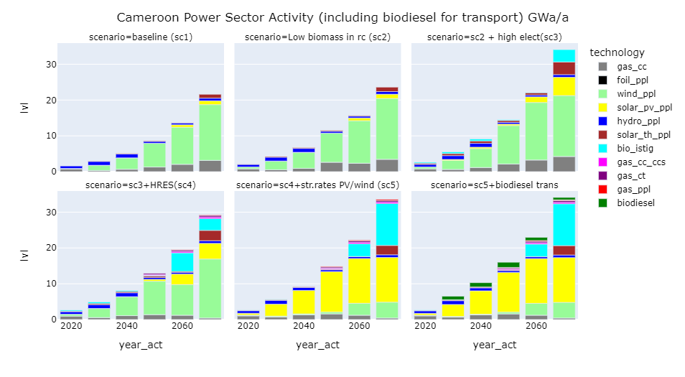**Figure 3:** Power sector activity (including biodiesel for transport sector); top (demand scenarios), bottom (supply scenarios)

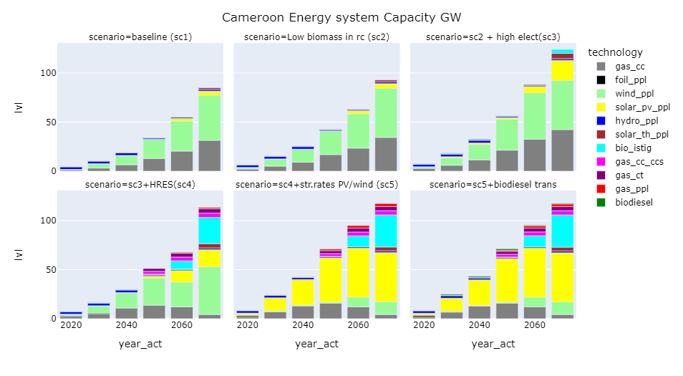

**Figure 4:** Power sector installed capacity

Scenarios 5 and 6 show the dominance of solar PV in the energy system due to impressive learning rates. Solar PV in these scenarios seems even more practical for a distributed and decentralized generation strategy, considering that many Cameroonians are not connected to the grid. However, as there is no distinction between utility PV and prosumer/standalone PV in the model, it is therefore vague to arrive at a proper conclusion from these results in light of decentralized PV systems.

Furthermore, biodiesel is considered a potential fuel option for the transport sector in scenario 6. However, the deployment of biodiesel is significantly low compared to the sizeable sustainable biomass potential. This is because the conversion of biomass to diesel has very low efficiency and, therefore not economical from a cost perspective.

1. **Emission Trajectories**

There is a decrease in the carbon emissions across scenarios in Figure 5 (top) due to the fact that a carbon price is included in all the scenarios. On the contrary, with no carbon tax involved, the emissions tend to increase or reduce at a slower rate which highlights that carbon taxing is a strong policy mechanism across all countries for emission reduction.

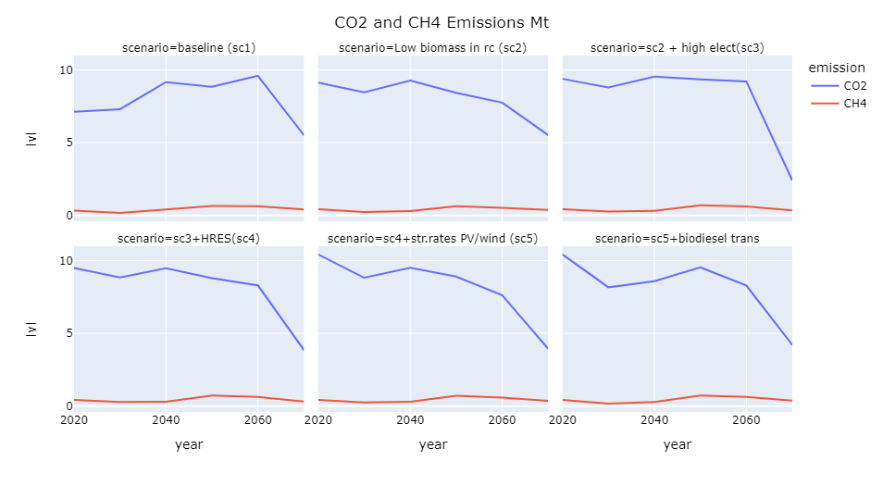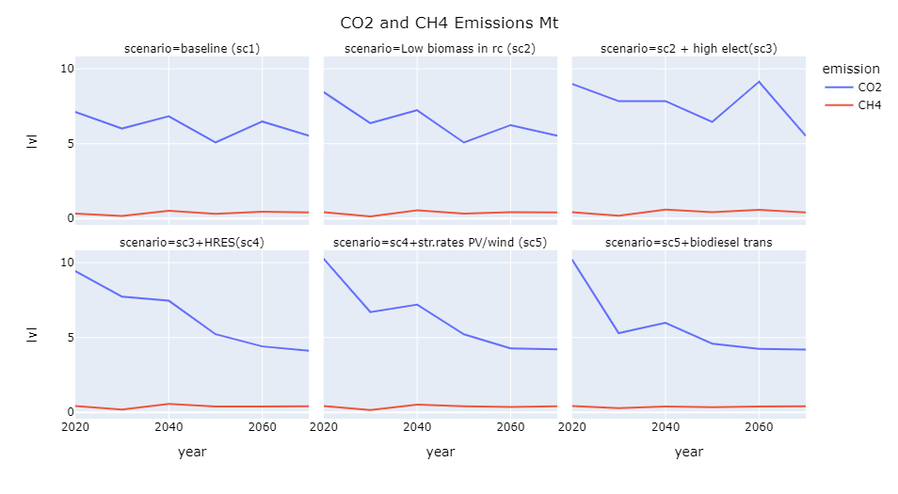

**Figure 5**: Emission Trajectories for all scenarios top(with carbon tax), bottom (without carbon tax)

1. **DISCUSSIONS**

They first insight from this study is that the cost of Cameroon’s energy system is expected to increase if high electricity access rates are to be achieved and clean energy solutions are to be introduced as shown in scenario 2 and 3 of the Table below. This means that strong investments are therefore needed from both the public and private sector.

|  |  |  |  |  |  |  |
| --- | --- | --- | --- | --- | --- | --- |
| ***Scenario*** | ***Scenario1*** | ***Scenario2*** | ***Scenario3*** | ***Scenario4*** | ***Scenario5*** | ***Scenario6*** |
| **cost (MUSD)** | 4380 | 4472 | 5536 | 5680 | 5290 | 5204 |

While the energy demand is most significant in the baseline scenario, the overall energy system activity is more significant in the high electrification access scenario for the demand-driven scenarios. While this seems contradictory, the change from large traditional biomass use to cleaner fuels needs a proper reconfiguration of the supply side of the energy system. Hence, greater activity in the high electrification access scenarios than in the baseline scenario which uses large biomass. Furthermore, in the high electrification access scenario, there is an immense growth in electricity demand in the residential and commercial sectors, thereby increasing the energy system’s activity to meet these requirements, unlike in the baseline scenario, which doesn’t require a large activity for biomass extraction. The activity for the power sector grows from 1.7 GWa/a in 2020 to 15 GWa/a in 2070 for the baseline scenario and to over 35 GWa/a in 2070 for the high electricity access scenario. Therefore, to increase the access rates in Cameroon, the power sector activity needs to double by 2070. A similar increase is expected in the installed capacity. In all scenarios, the power sector is highly reliant on renewables, particularly solar PV and wind, with little development of hydropower. It should be noted that Cameroon’s policy institutions have been so determined to develop the hydropower resource. Over seven hydropower projects have been planned [11] and the resource potential of hydropower in Cameroon has sometimes been branded as sufficient to supply the entire central African region [10]. However, the simulation result suggests that hydropower is not a dominating least-cost solution. Instead, policy should focus on developing either solar or wind as renewable alternatives, which has been lacking from the existing policy plans. However, a useful technology missing from this analysis is the storage infrastructure, especially lithium-ion batteries, which will be pivotal in storing excess renewable electricity generated. As storage technologies are not accounted for in the model, the results could be subjected to two potential pitfalls. Firstly, the choice of technology installed ( in this case, renewable energy technologies) may not meet the required demand when a higher time resolution is considered, like days or weeks, due to variability in the wind and sun availability. In addition, the system cost would increase if battery storage were considered and thereby likely distorting the overall configuration of the supply technologies. A more complementary energy system technology could be expected if storage costs were to be included in renewable energy generation systems. The dominance of wind and solar will in Cameroon’s energy system will not only depend on the cost of the technologies but the associated cost of compatible storage options.

The emission trajectories reveal that, for 30 USD/tCO2, the emissions across all scenarios will decrease compared to present-day emissions, which positively contribute to climate mitigation. The emissions in the supply scenarios reduce more strongly than those in the demand scenarios. This will even be more important as Cameroon’s economy is still developing. The demand for end-use energy services is bound to increase, thereby making supply configurations a more practical way to reduce emissions within the energy system.

Biodiesel production from sustainable biomass can be envisaged for Cameroon due to abundant biomass potential. However, the large deployment of biodiesel is inhibited by the cost of the conversion system and the low conversion efficiency of feedstock to biodiesel. To test the effects of efficiency on the activity of the energy system in line with biodiesel as a fuel for the transport sector, the efficiency of biodiesel conversion is systematically varied between 13 and 40%. The results obtained are displayed in Figure 6.

**Figure 6**: Sensitivity of biodiesel activity to conversion efficiency

Doubling the efficiency also results in an average double of the biodiesel activity, which signifies the effects of the conversion system's efficiency on biodiesel production. However, it is essential to emphasise the conversion yield is dependent on both the choice of technology and the biomass feedstock (wood residues, biofuel crops, etc.).

1. **COMPARING CAMEROON AND SOUTH AFRICAN ENERGY SYSTEMS**

The section attempts to compare the performance of Cameroon’s energy system to that of South Africa. It is essential to mention that several attributes distinguish these two economies. Firstly, South Africa is one of the largest economies in Africa, with a GDP of about 335 billion USD (current USD), while Cameroon’s GDP is estimated at 41 billion, eight times lower than that of South Africa.[12]. South Africa’s GDP is projected to grow to 2491 billion USD by 2070 while that of Cameroon only grows to 322 billion USD [13]. Cameroon’s GDP in 2070 is eight times lower than South Africa’s GDP. Furthermore, the electric consumption per capita in South Africa is 4.2MWh while that of Cameroon is 0.28MWh, 15 times lower than that of South Africa. South Africa largely depends on coal, while Cameroon has a mix of hydro, natural gas, and oil. The difference in the evolution of each country’s energy system can therefore be expected to display similar disparities following the current economic attributes. South Africa’s energy demand in 2050 is 133GWa/a which is approximately 7-8 times larger than the maximum energy demand for all the scenarios in Cameroon. The objective function for the South African baseline model is 63 billion USD which is about 16 times higher than Cameroon’s 4 billion USD in the baseline scenarios. The system cost represents similar order of magnitude to the per capita energy consumption. This indicates that the results from Cameroon are accurately calibrated based on the initial South African model.

1. **Conclusion**

The simplified energy system model described in this half paper illustrates the evolution of Cameroon’s energy system. While there are several limitations to the technology, like excluding storage options and geothermal resources, the basic energy system gives insights into the likely evolution of Cameroon’s energy system. We remark on the dominance of variable renewables, whose deployment is further amplified if the learning rates are steeper. Hydropower doesn’t seem to be a good solution for Cameroon in the long term, but instead, advanced biomass power plants (bio_istig) will grow significantly into the future. In addition, we see that emission reduction strategies in Cameroon should focus more on the supply configurations as demand for essential energy services will increase in the future.

1. **References**

1. Orthofer, C.L.; Huppmann, D.; Krey, V. South Africa after Paris-fracking its way to the NDCs? *Front. Energy Res.* **2019**, *7*, 1–15, doi:10.3389/fenrg.2019.00020.

2. International Energy Agency (IEA) Clean Cooking Database Available online: https://www.iea.org/reports/sdg7-data-and-projections/access-to-clean-cooking (accessed on Apr 20, 2022).

3. International Energy Agency (IEA) Data tables – Data & Statistics Available online: https://www.iea.org/data-and-statistics (accessed on Jul 20, 2020).

4. Bogdanov, D.; Ram, M.; Aghahosseini, A.; Gulagi, A.; Oyewo, A.S.; Child, M.; Caldera, U.; Sadovskaia, K.; Farfan, J.; De Souza Noel Simas Barbosa, L.; et al. Low-cost renewable electricity as the key driver of the global energy transition towards sustainability. *Energy* **2021**, *227*, 120467, doi:10.1016/j.energy.2021.120467.

5. Barasa, M.; Bogdanov, D.; Oyewo, A.S.; Breyer, C. A cost optimal resolution for Sub-Saharan Africa powered by 100% renewables in 2030. *Renew. Sustain. Energy Rev.* 2018.

6. Oyewo, A.S.; Asfaw, A.S.; Bogdanov, D.; Aghahosseini, A.; Mensah, T.; Breyer, C. Transition towards a decarbonised energy system for developing economies: A case study of Ethiopia. **2020**.

7. Huang, W.D.; Zhang, Y.H.P. Energy efficiency analysis: Biomass-to-wheel efficiency related with biofuels production, fuel distribution, and powertrain systems. *PLoS One* **2011**, *6*, 1–10, doi:10.1371/journal.pone.0022113.

8. US EIA Cameroon-Energy Statistics Available online: https://www.eia.gov/international/data/country/CMR (accessed on Apr 20, 2022).

9. Hermann, S.; Miketa, A.; Fichaux, N. Estimating the Renewable Energy Potential in Africa: A GIS-based approach. *IRENA-KTH Work. Pap.* **2014**, 70.

10. Kenfack, J.; Nzotcha, U.; Voufo, J.; Ngohe-ekam, P.S.; Calvin, J.; Bignom, B. Cameroon’s hydropower potential and development under the vision of Central Africa power pool ( CAPP ): A review. *Renew. Sustain. Energy Rev.* **2021**, *151*, 111596, doi:10.1016/j.rser.2021.111596.

11. MINEE Cameroon *A Study for Establishment of the Master Plan of Renewable Energy in Cameroon*; 2017;

12. World Bank Group (WBG) GDP Statistics Cameroon and South Africa Available online: https://data.worldbank.org/indicator/NY.GDP.MKTP.CD?locations=ZA-CM (accessed on Apr 27, 2022).

13. Crespo Cuaresma, J. Income projections for climate change research: A framework based on human capital dynamics. *Glob. Environ. Chang.* **2017**, *42*, 226–236, doi:10.1016/j.gloenvcha.2015.02.012.